Misc Settings

On this tab you can change values that will affect every car you drive or every computer car.

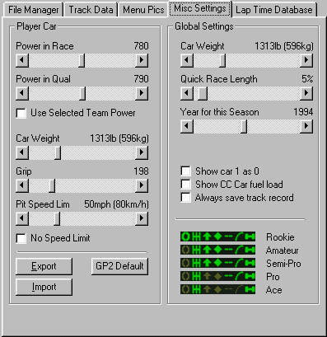
(Misc Settings)

Player Car

Power in Race, you can select how much HP you want your car to have in the Race.

Power in Qual, same as Power in Race but this change the HP in Qual.

Use Selected Team Power, you will have as many HP as the car you drive have, if you drive a Ferrari you will have more power then if you drive a Minardi.

Car Weight, add more weight to you car or remove some weight.

Grip, set how much grip your car will have. Low value=high grip and high value=low grip.

Pit Speed, change the pit speed limit, some track’s have 80 km/h and some have 120 km/h, this will NOT change the Computer cars pit speed (!).

No Speed Limit, remove the pit speed limit, this will NOT change the computer cars pit speed (!).

Global Settings:

Car Weight, set the weight of the computer cars.

Quick Race Length, change the length of a quick race in % of a 100% race, e.g. Monaco 100% is 78 laps and quick race with 35%=27 laps.

Year for this Season, change the text in the race settings windows in Gp2 from 1994 to another year. Click on the text to enter a year or move the slider.

Show Car 1 as 0, driver number 1 will appear in the game as number 0. This allows you to simulate the 1993 and 1994 seasons when the previous seasons World Champion (number 1) didn't participate.

Show CC Car Fuel Load, this will enable you to se the CC Car fuel load.

Always save track record, by default Gp2 only saves a new track record if you break it in a 100% race but with this option Gp2 will always save a new track record.

You can also change the driver aids available at different levels in the game.

Import, import all settings from Gp2.

Export, export all changes to Gp2.

Gp2 Default, set all values to the default values.

